Khi User bao ket OPS 240

1 . Copy so Pick

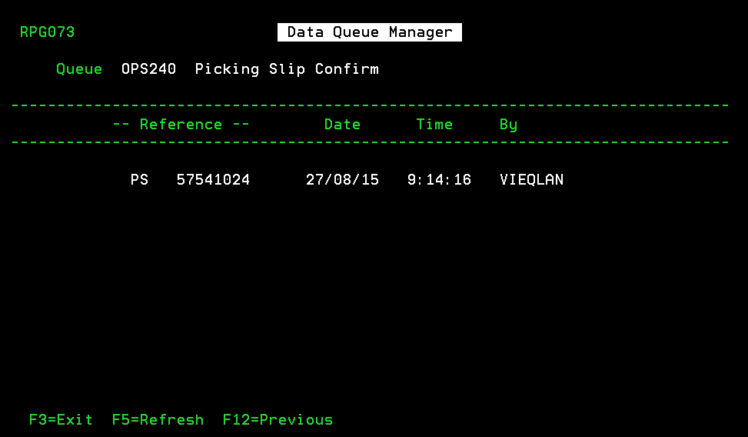

2. Tu man hinh SDS nhan Esc chon 20

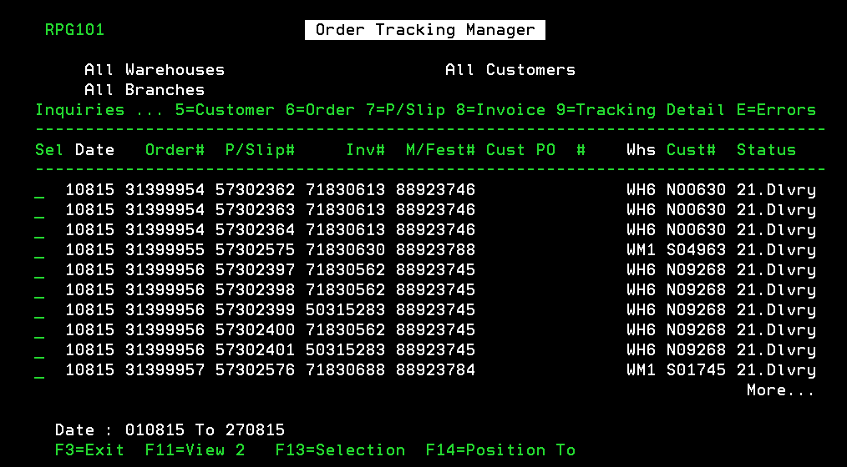

Nhan Shift + F1 , Shift Tab , chon thanh so 2 , enter

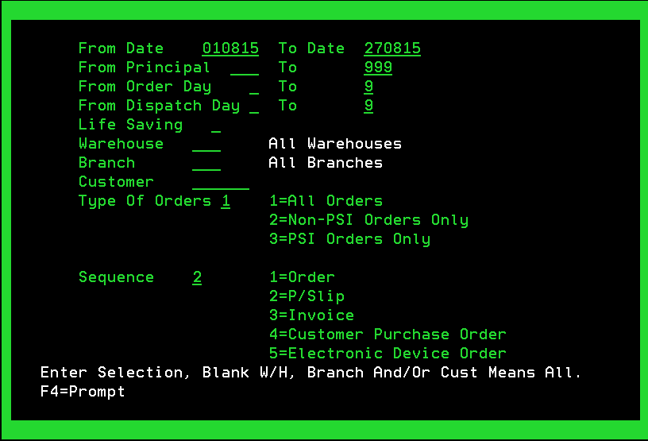

Chon shift + f2 , paste so pick vao , enter

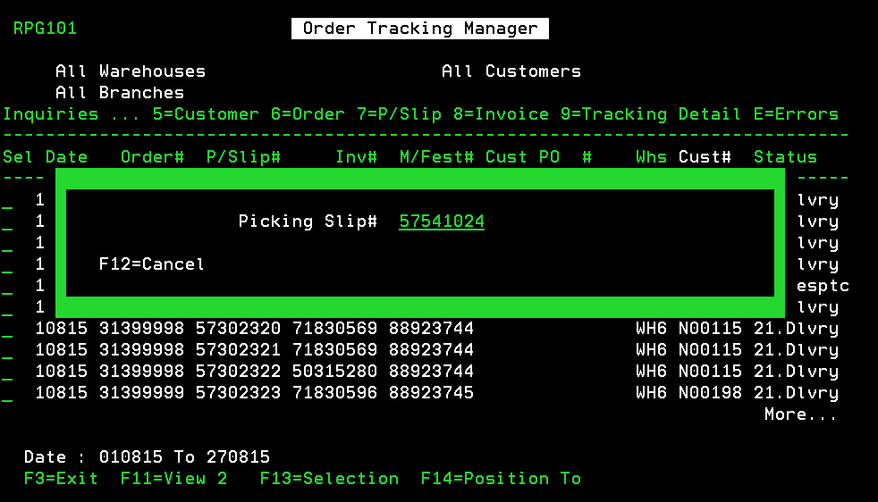

Kiem tra dung so pick khong ? , OPS240 o thong bao sau do chon so 7

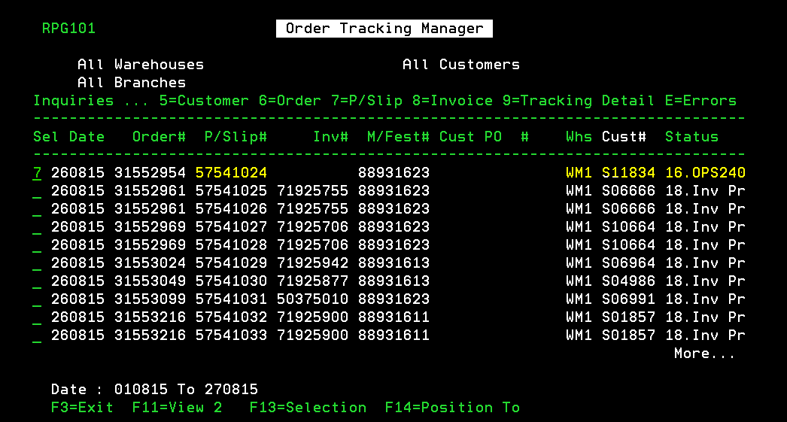

Copy so hoa don

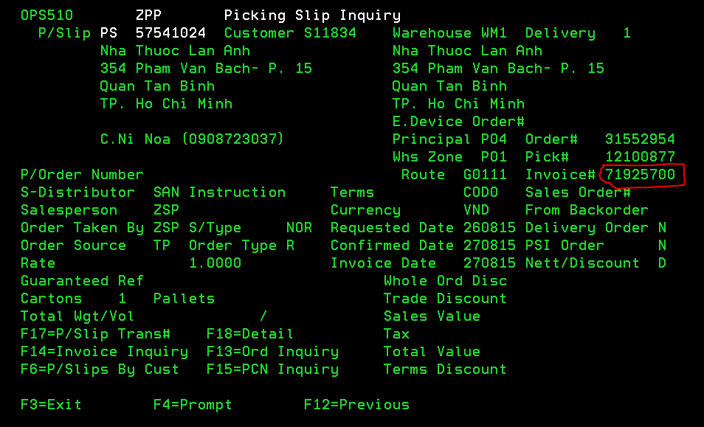

Chay SQL

select indsts from ind

where ttype='IV' and invno=71925700

* Neu INDSTS la A , B, AB

Thoat ve man hinh chinh, go lenh

CALL PGM(OPS241CA) PARM('01OPS241CA' 'PS' 'xxxxxxxx')

( XXXXXXX : la so pick luc dau tien 57541024 )

Check lai bang cach vao lai ESC20 , xem tinh trang pick , cho den khi nao xuat hien

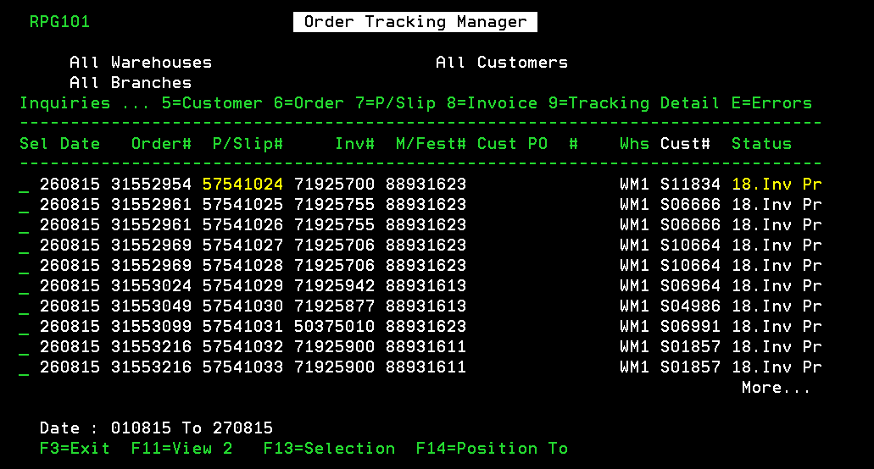

Status la Inv Pri la ok .

* Neu INDSTS la E,F,EF
* CALL PGM(OPS245CA) PARM('01OPS245CA' 'PS' 'nnnnnnnn')